Name: ___________________________

Arrays, pointers, and characters

0] Review problem on arrays and loops. In the previous lab we solved this problem:

Write a program that declares an array of 50 elements and then places in it the square roots of the numbers from 1 to 50. Print the array on one line.

1. Modify the code you already have to print 10 elements on each line.
   1. Hint: Figure out when we need to print newline characters. For practice, use **putchar** to print them!

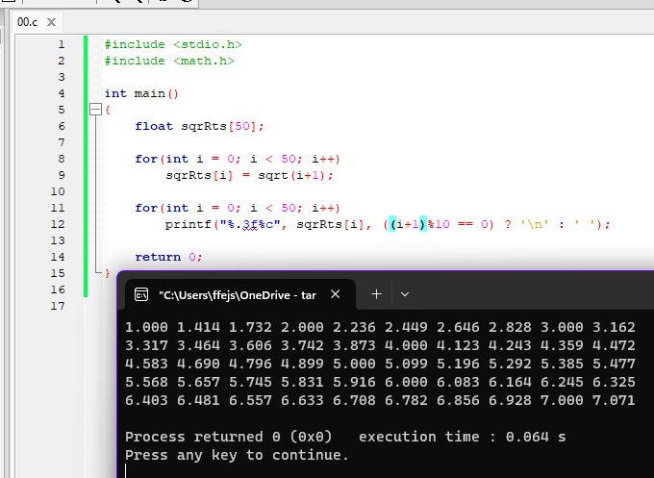

1. Modify the code you already have to print k elements on each line, where k is an integer entered by the user.

Note:

For passing an array to a function, send as arguments: the name of the array, and an integer for the size, like this: **sumarrays( array, 10 )**

For the header of the function (and prototype), indicate the array with empty square brackets and the integer size, like this: int **sumarrays( int array[], int size )**

1] From ch.9:

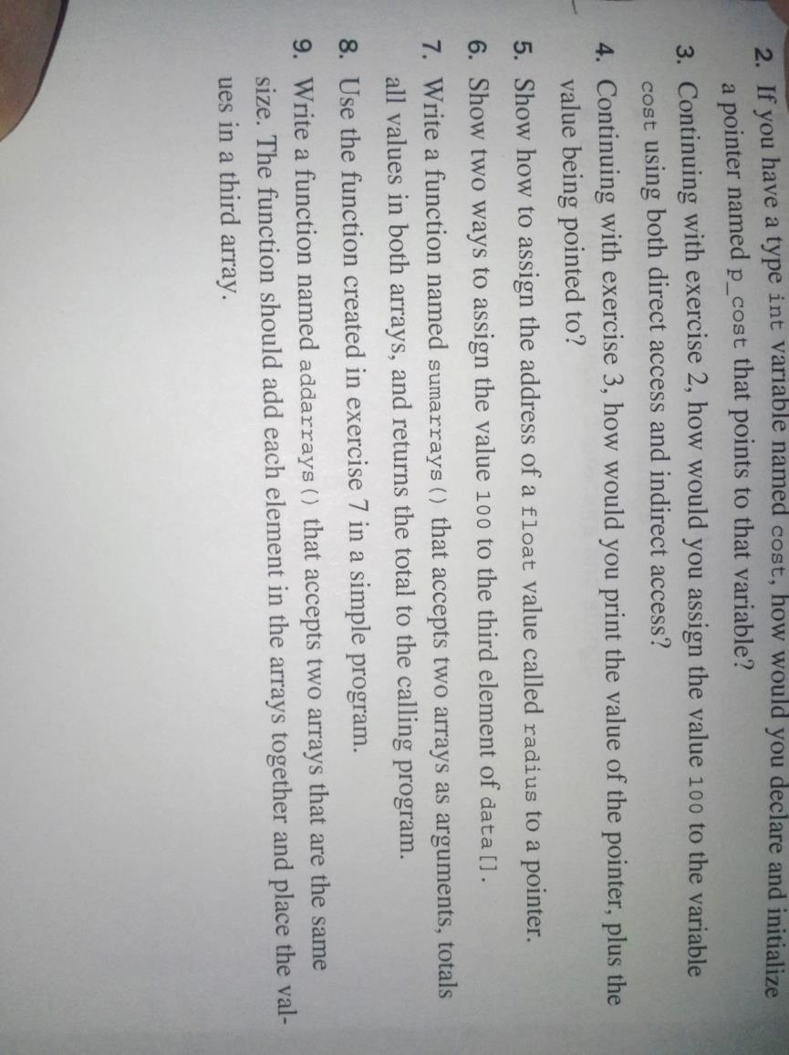

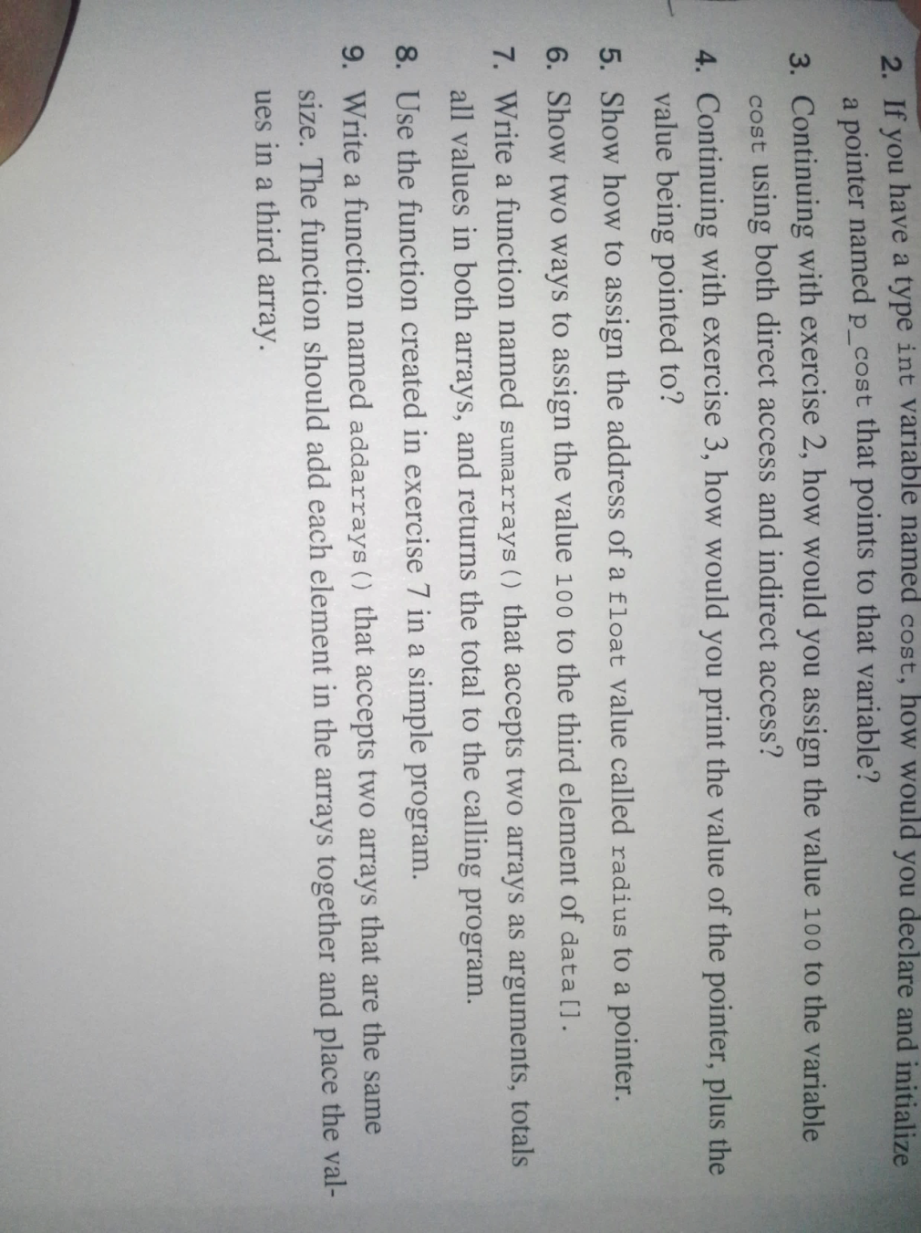

2] (Similar to above): Write a function that accepts two arrays as arguments, and makes a reversed copy of the first array in the second. The data type is up to you.

Use the function in a program, with arrays of size 8; after calling the function, print both arrays and make sure it works!

3] Write a complete C program to declare and initialize a 10x10 matrix with this pattern of elements. (Main diag. is all 0s)

Hint: You have to spot a relationship between the indices i, j of each element, and the value stored in that element.

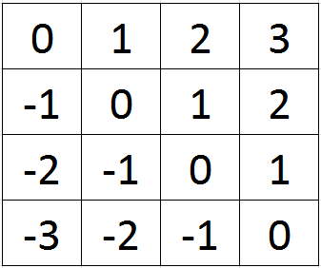

**To be reported on canvas:**

4] ► Write a C program with a function that takes an array of floats as argument and calculates the product of all elements. Test the program with the array 1.1 2.2 3.3 4.4 5.5.

Hint: The length of the array is known inside the function since it was passed as an argument!

5] ► Write a complete C program to declare and initialize an 11x11 matrix with this pattern of elements. (The diags. do cross!)

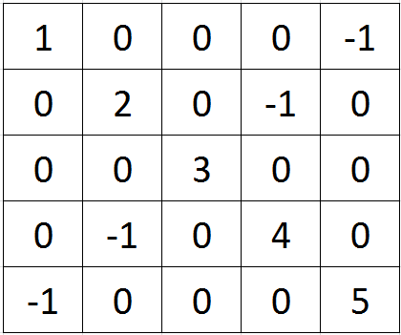

6] ► Write a complete C program to declare and initialize a 10x10 matrix with this pattern of elements:

Hint: You have to spot a relationship between the indices i, j of each element, and the value stored in that element.



